IT5016: Software Development fundamental
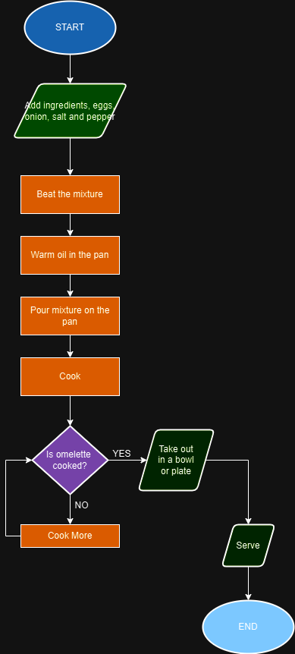

- Pseudocode Code

- Start
- Add ingredients, eggs, onion, salt and pepper
- Beat the mixture
- Warm oil in the pan
- Pour mixture on the pan
- Cook
- Is omelette cooked?
- Yes/No
- If no cook more
- If yes take out in the bowl or plate
- Serve
- End

